**Practical 8:**

**Objective**: Solving Linear Systems (Jacobi and Gauss-Seidel)

**Part A: (Excel - Matrix Inversion)**

1. Use Excel to solve for the unknowns.

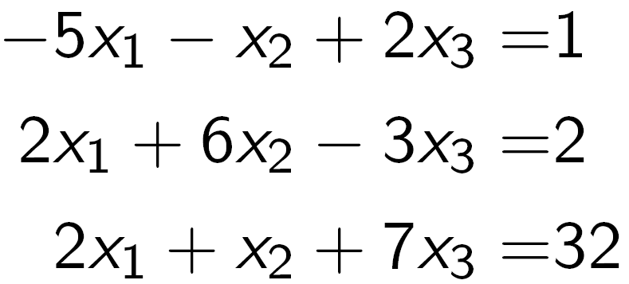

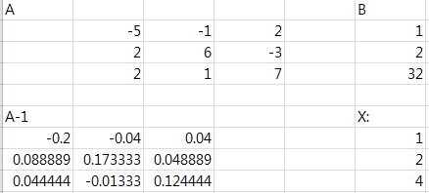

1. Use Excel to solve for the unknowns.

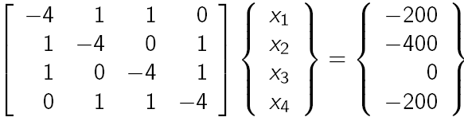

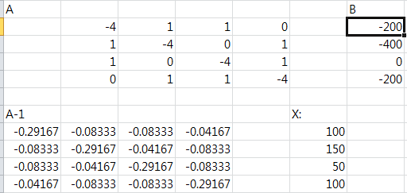

**Part B: (Jacobi and Gauss-Seidel)**

The Jacobi iteration and Gauss-Seidel methods are not guaranteed to converge on the exact answer in every possible case and every possible initial guess. However, if the equations in the system are diagonally dominant, then the Jacobi iteration and Gauss Seidel methods are guaranteed to converge regardless of the starting guess for $x$.

Diagonal dominance is defined as the condition where the coefficient along the diagonal on any row is larger in absolute value than the sum of the absolute values of the other coefficients on the same row. Matrix A is diagonal dominance if

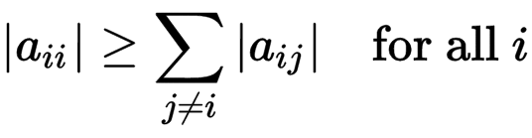

**Example:**



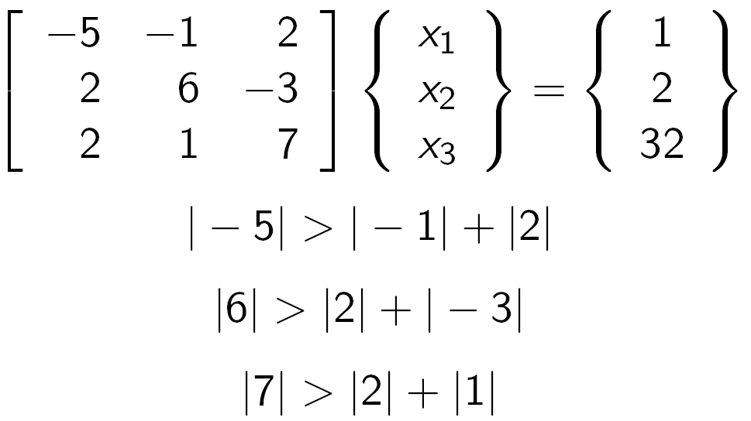

This system of equations is diagonally dominant. Therefore, we will converge to the exact solution regardless of the values of $x_{i}$ we start with.

Mike

Use a stopping criterion of $ε_{s}=5\%$ to solve the following system

$$-8x_{1}+x_{2}-2x_{3}=-20$$

$$-3x_{1}-x_{2}+7x_{3}=-34$$

$$2x_{1}-6x_{2}-x_{3}=-38$$

1. Jacobi
2. Gaussian-Seidel

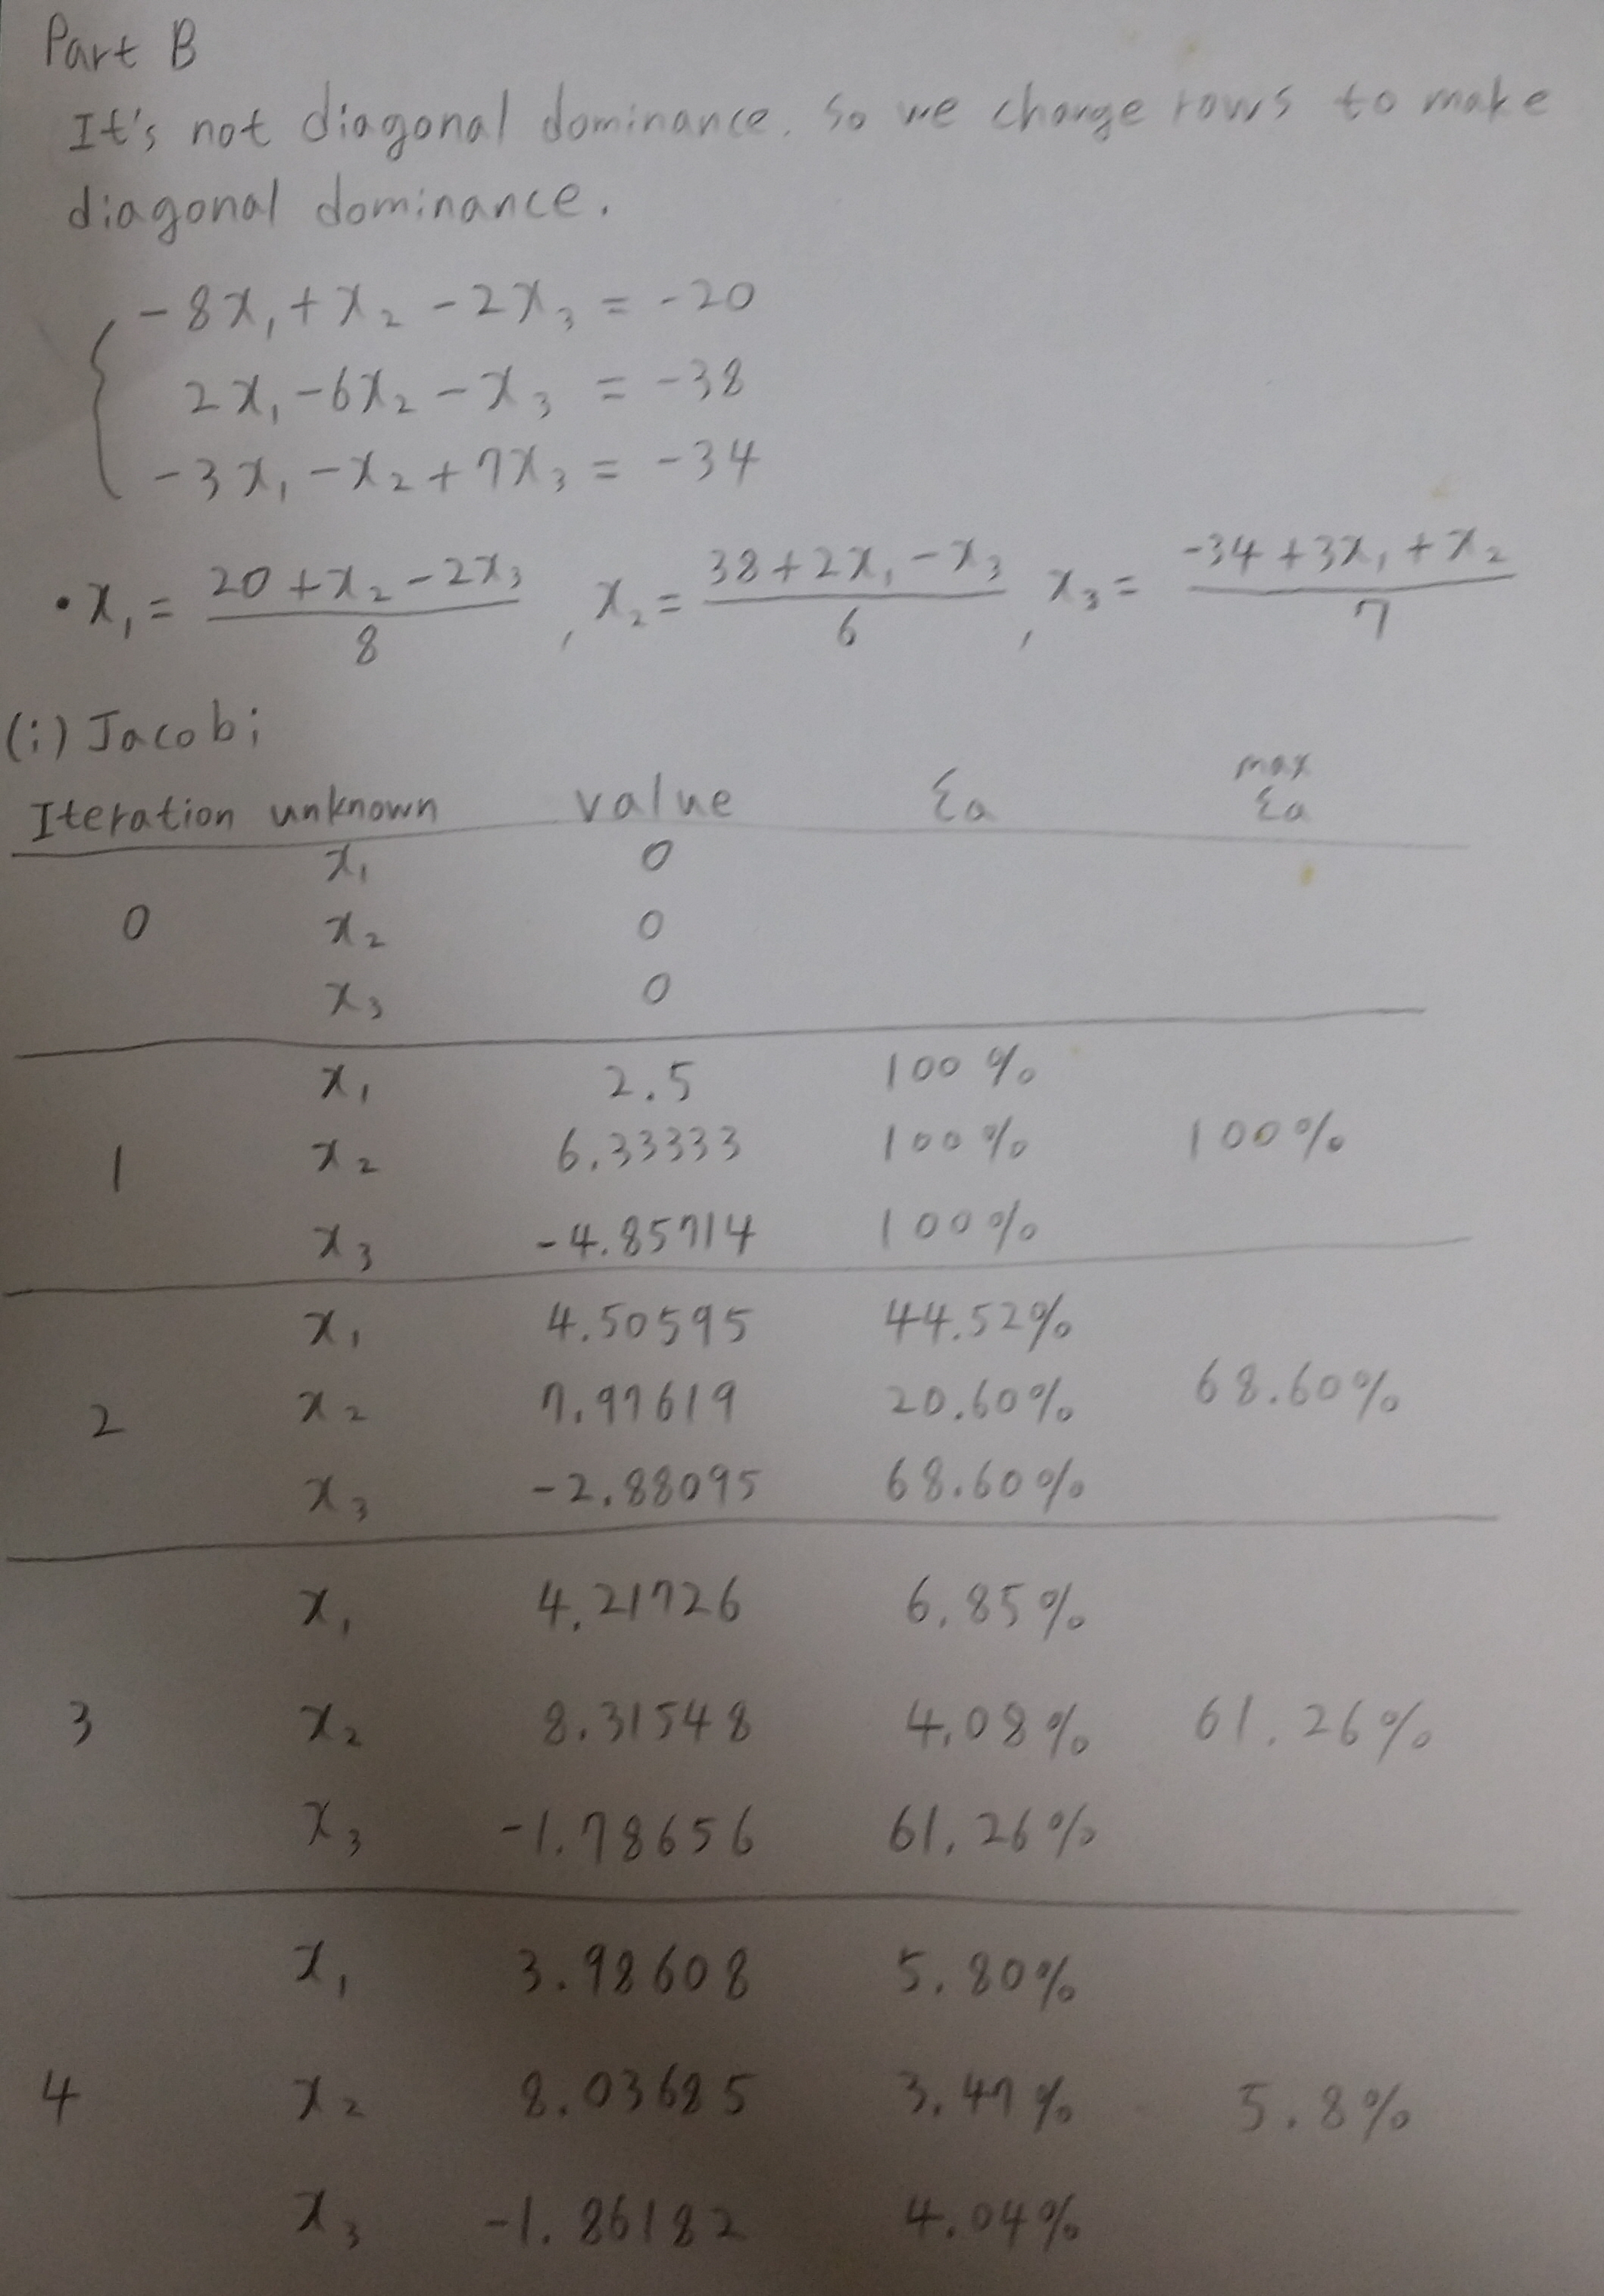

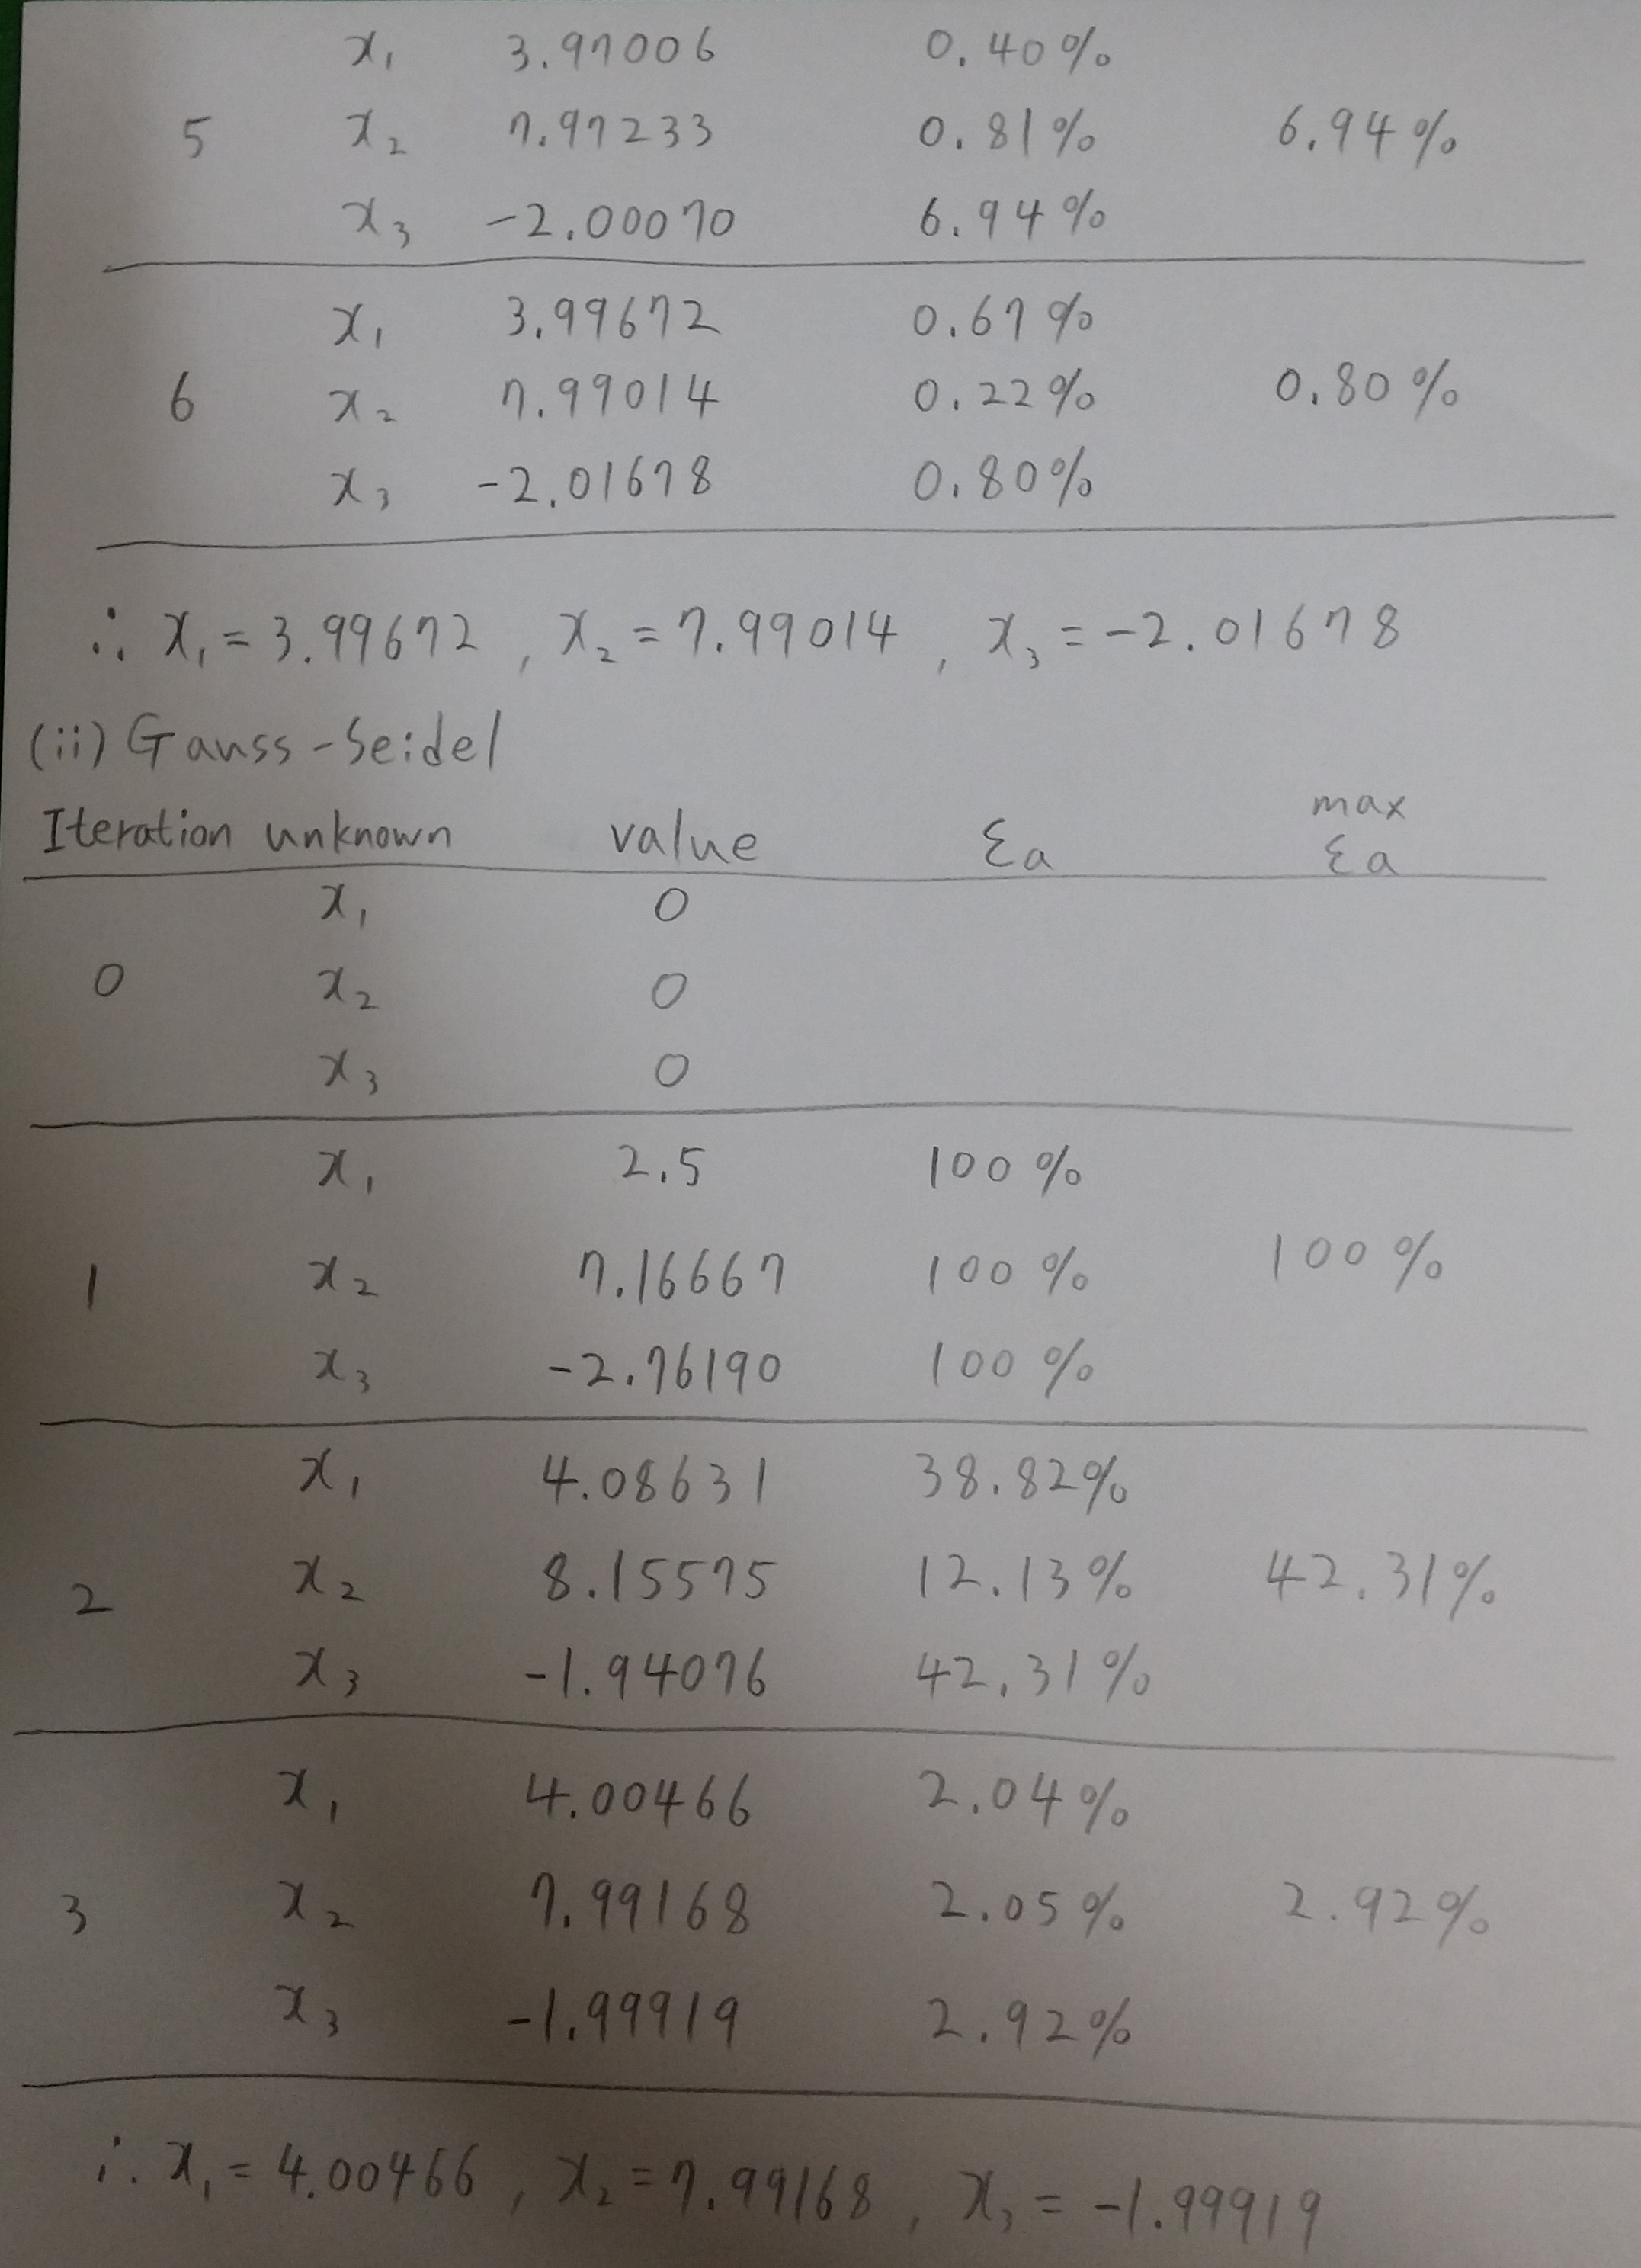

**Part C: (Gauss-Seidel with Relaxation)**

To enhance convergence, an iterative program can introduce relaxation where the value at a particular iteration is made up of a combination of the old value and the newly calculated value:

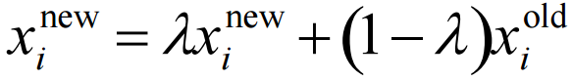

where $λ$ is a weighting factor that is assigned a value between 0 and 2

* $0<λ<1$: underrelaxation
* $λ=0$: no relaxation
* $1<λ≤2$: overrelaxation

The choice of a proper value for $λ$ is highly problem-specific and is often determined empirically.

Use Gaussian-Seidel with overrelaxation ( $λ=1.2)$ and a stopping criterion of $ε_{s}=5\%$ to solve the following system

$$-8x_{1}+x_{2}-2x_{3}=-20$$

$$-3x_{1}-x_{2}+7x_{3}=-34$$

$$2x_{1}-6x_{2}-x_{3}=-38$$

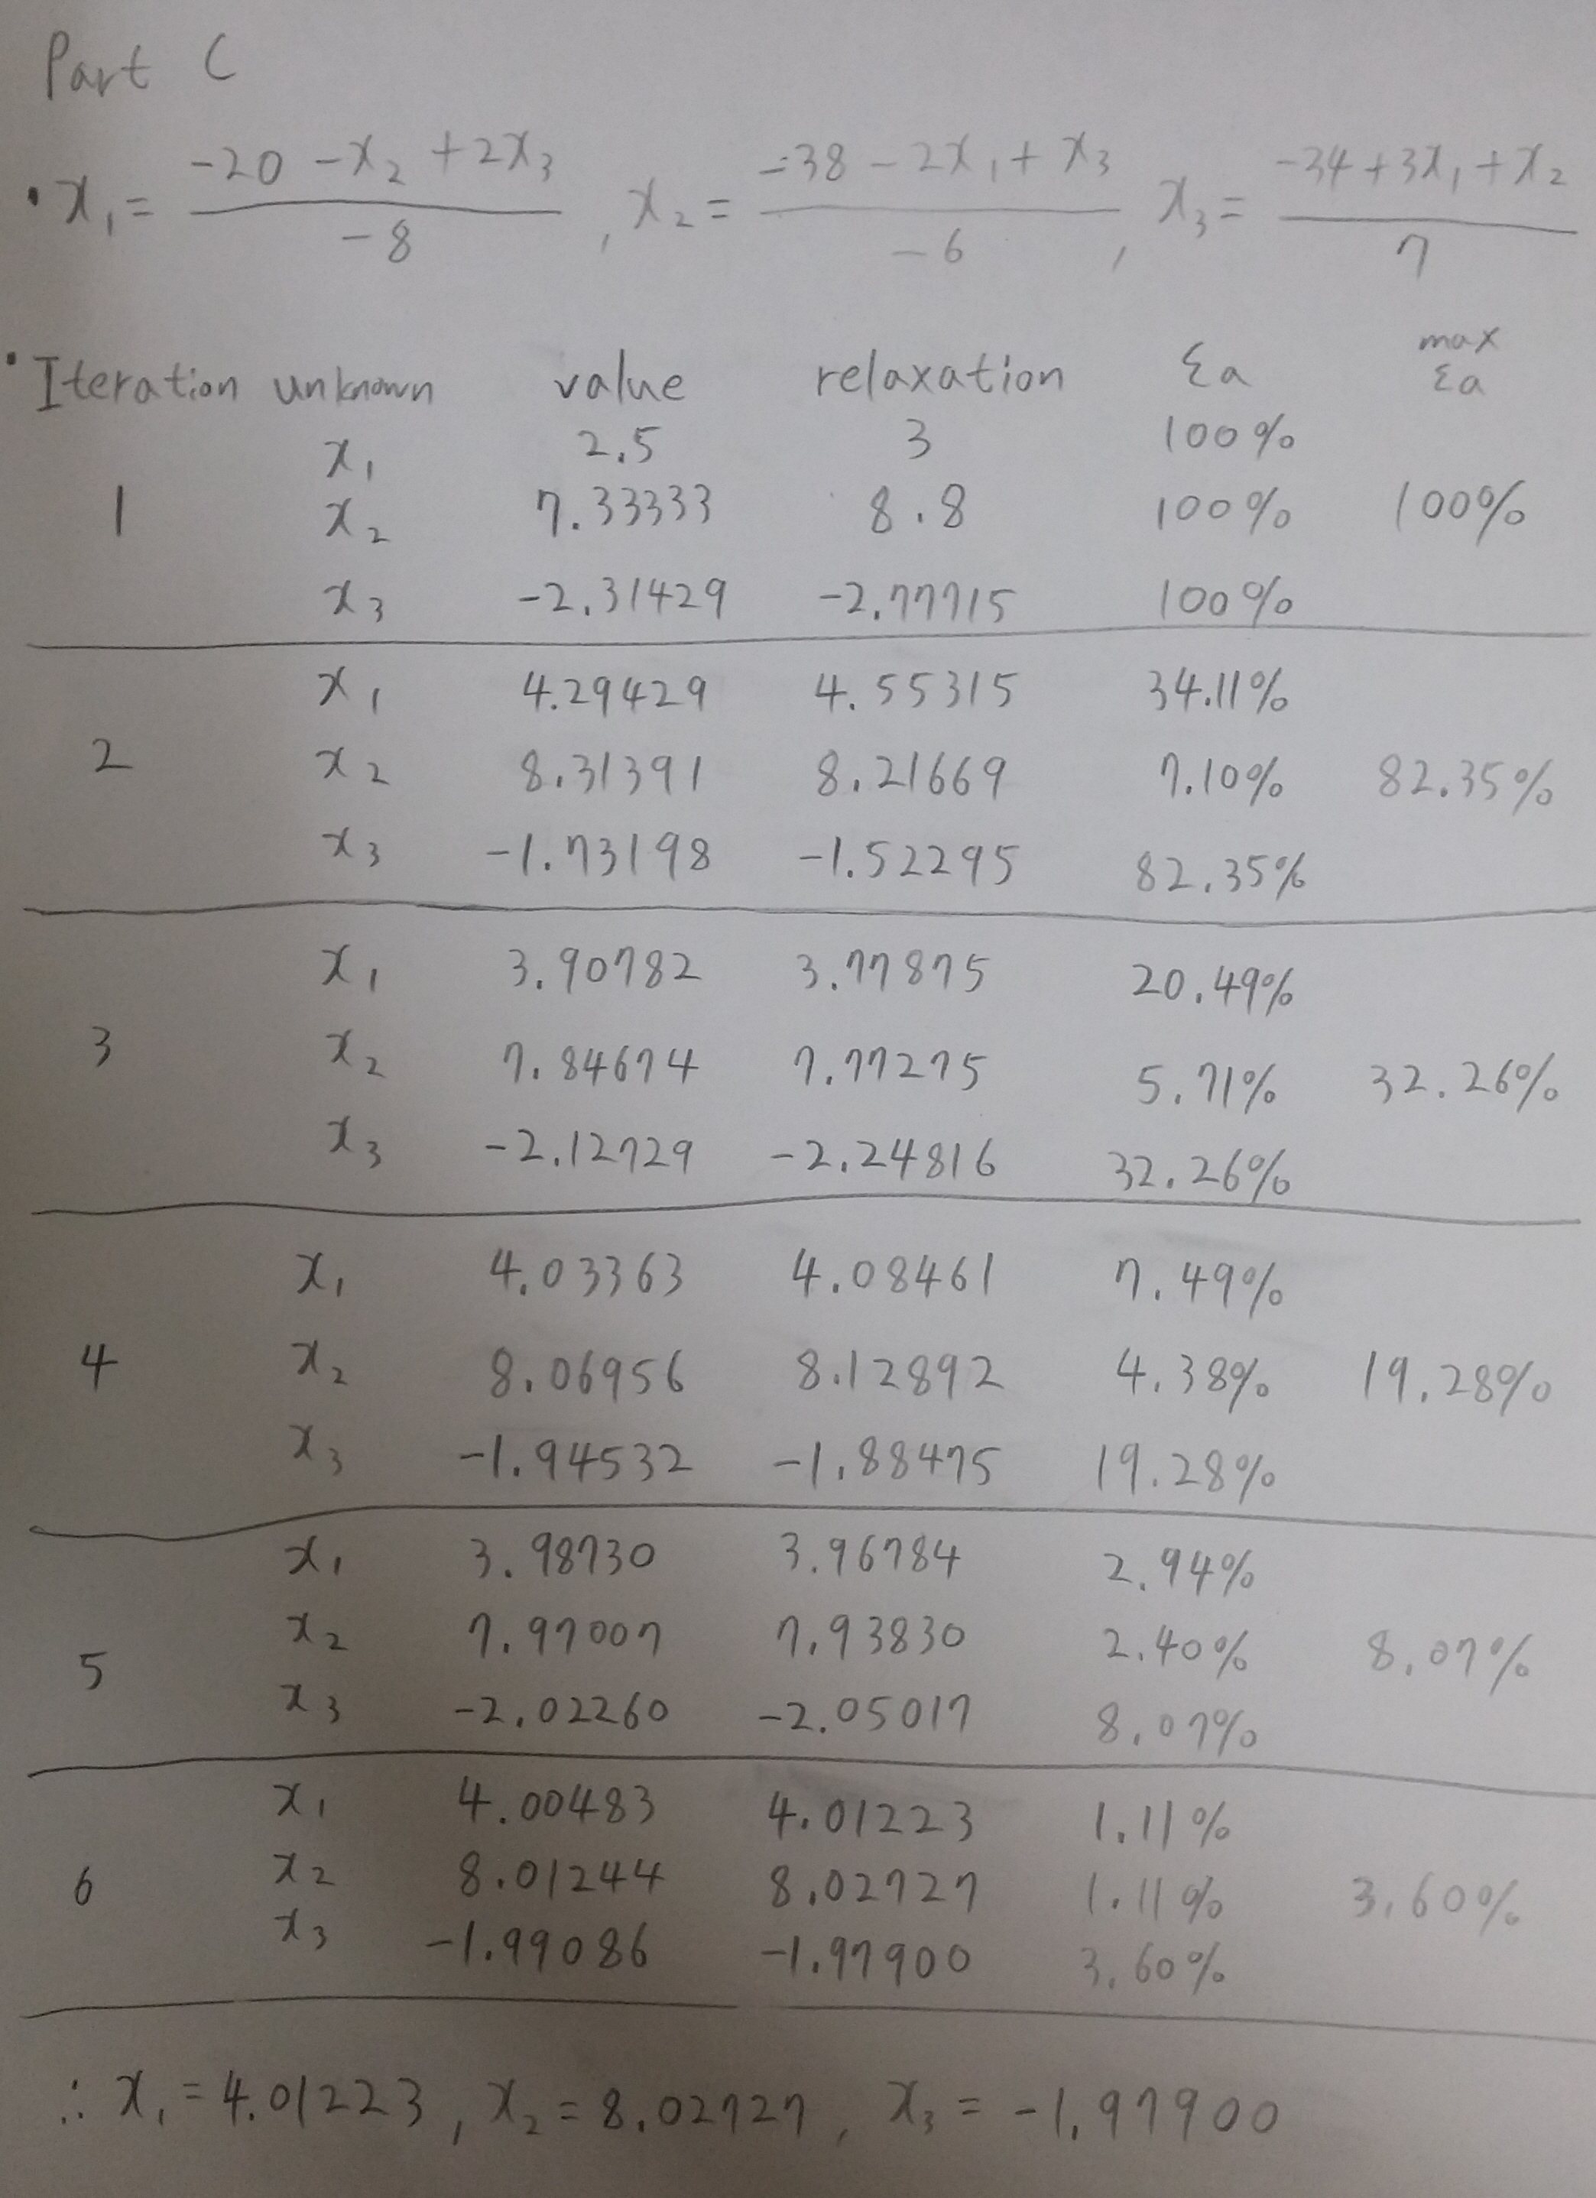

**Part D: Programming Practice**

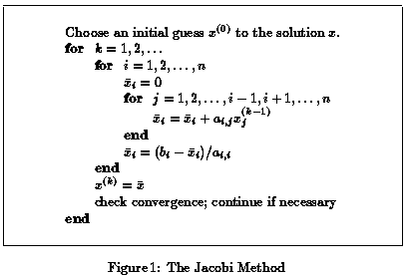

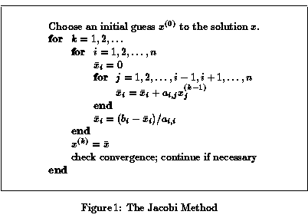

1. Write a Jacobi program to solve a system with 3 linear equations.
2. Write a Gaussian-Seidel program to solve a system with 3 linear equations.
3. Write a Gaussian-Seidel program (with relaxation) to solve a system with 3 linear equations.